Thomas Crow

CS120

Exam #2 Question #1

Output #1

* Note: I’m not sure how to show 5 clicks on the output.

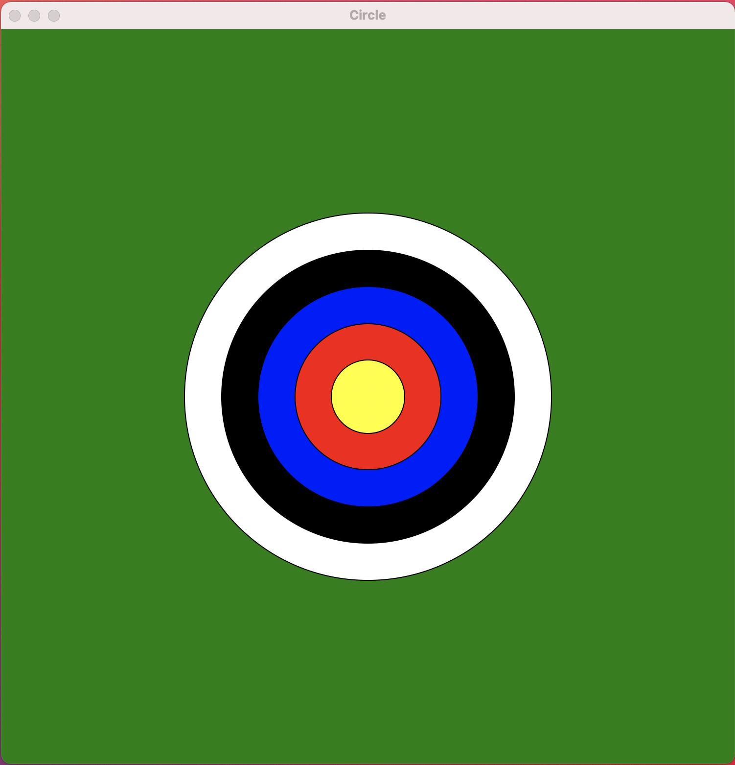

Run #1 (One of each scoring ring)

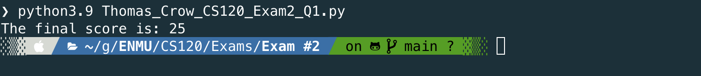

Run #2 (All bullseyes)

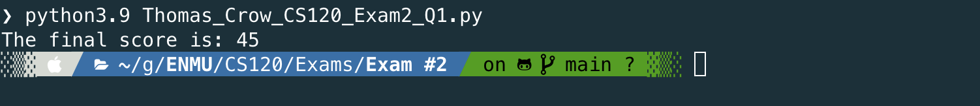

Run #3 (All Misses)

